Assignment-3

PythonProgramming

|  |  |
| --- | --- |
| StudentName | Sree Deekshana P |
| StudentRollNumber | 1902228 |

Question-1:

Write python code for blinking LED and Traffic lights for Raspberry pi.Only python code isenough, no need to execute in raspberry pi.Note: you are allowed to use web search and completetheassignment.

CODE:

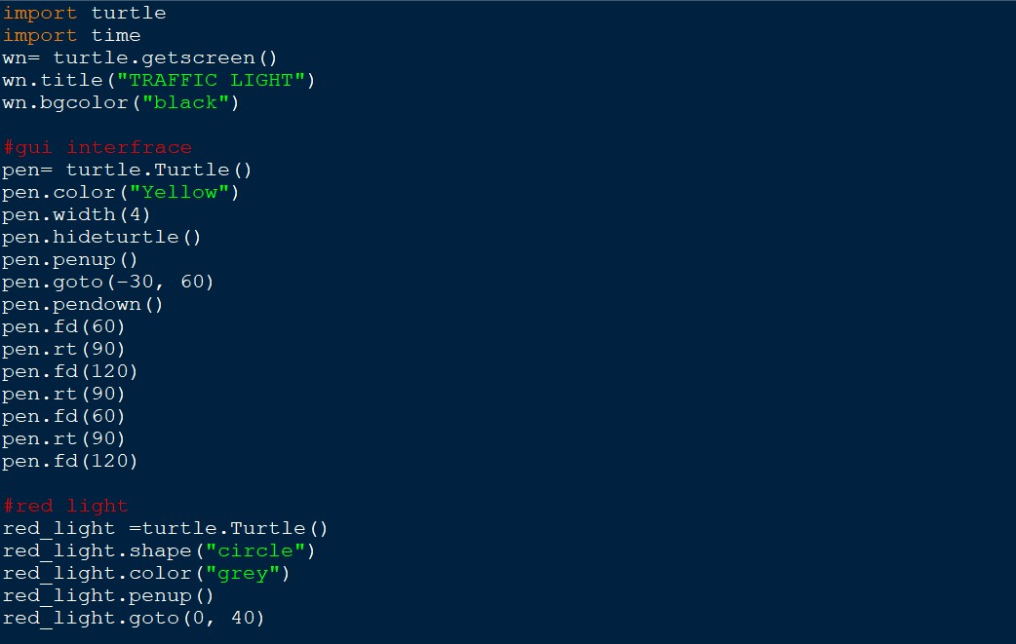

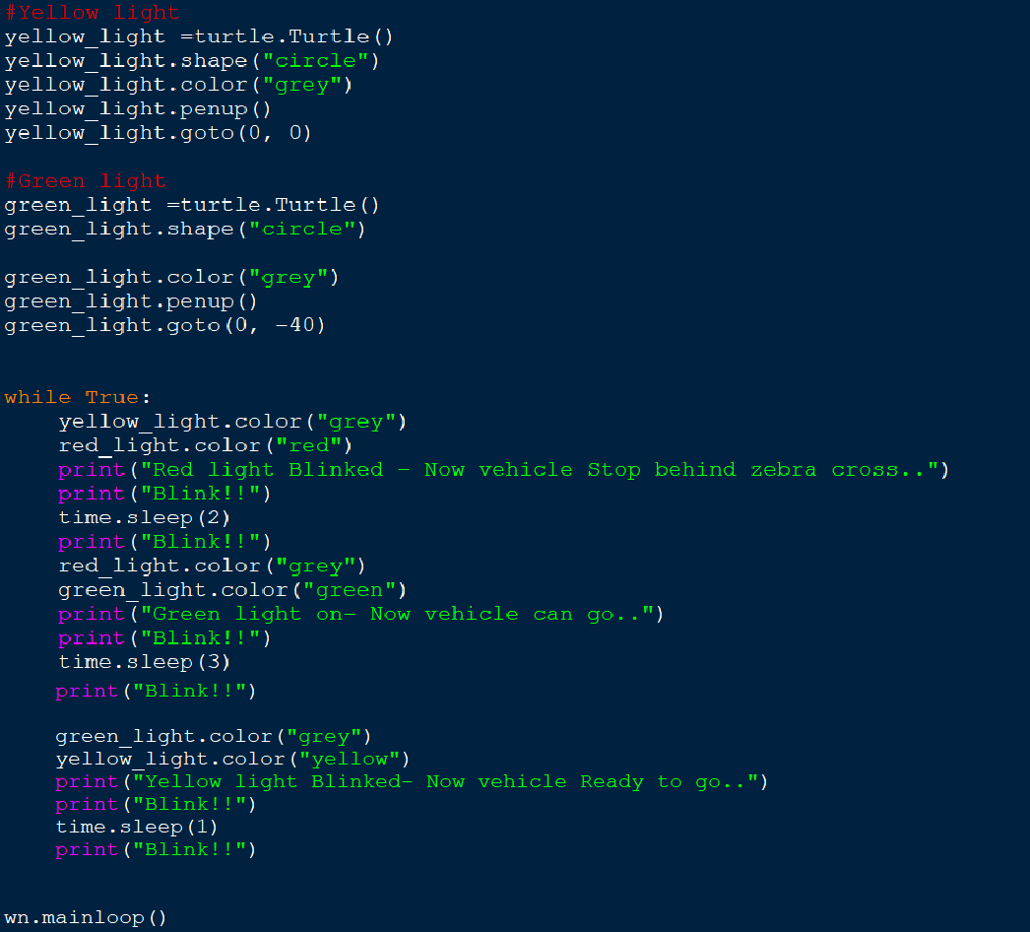

**OUTPUT:**

